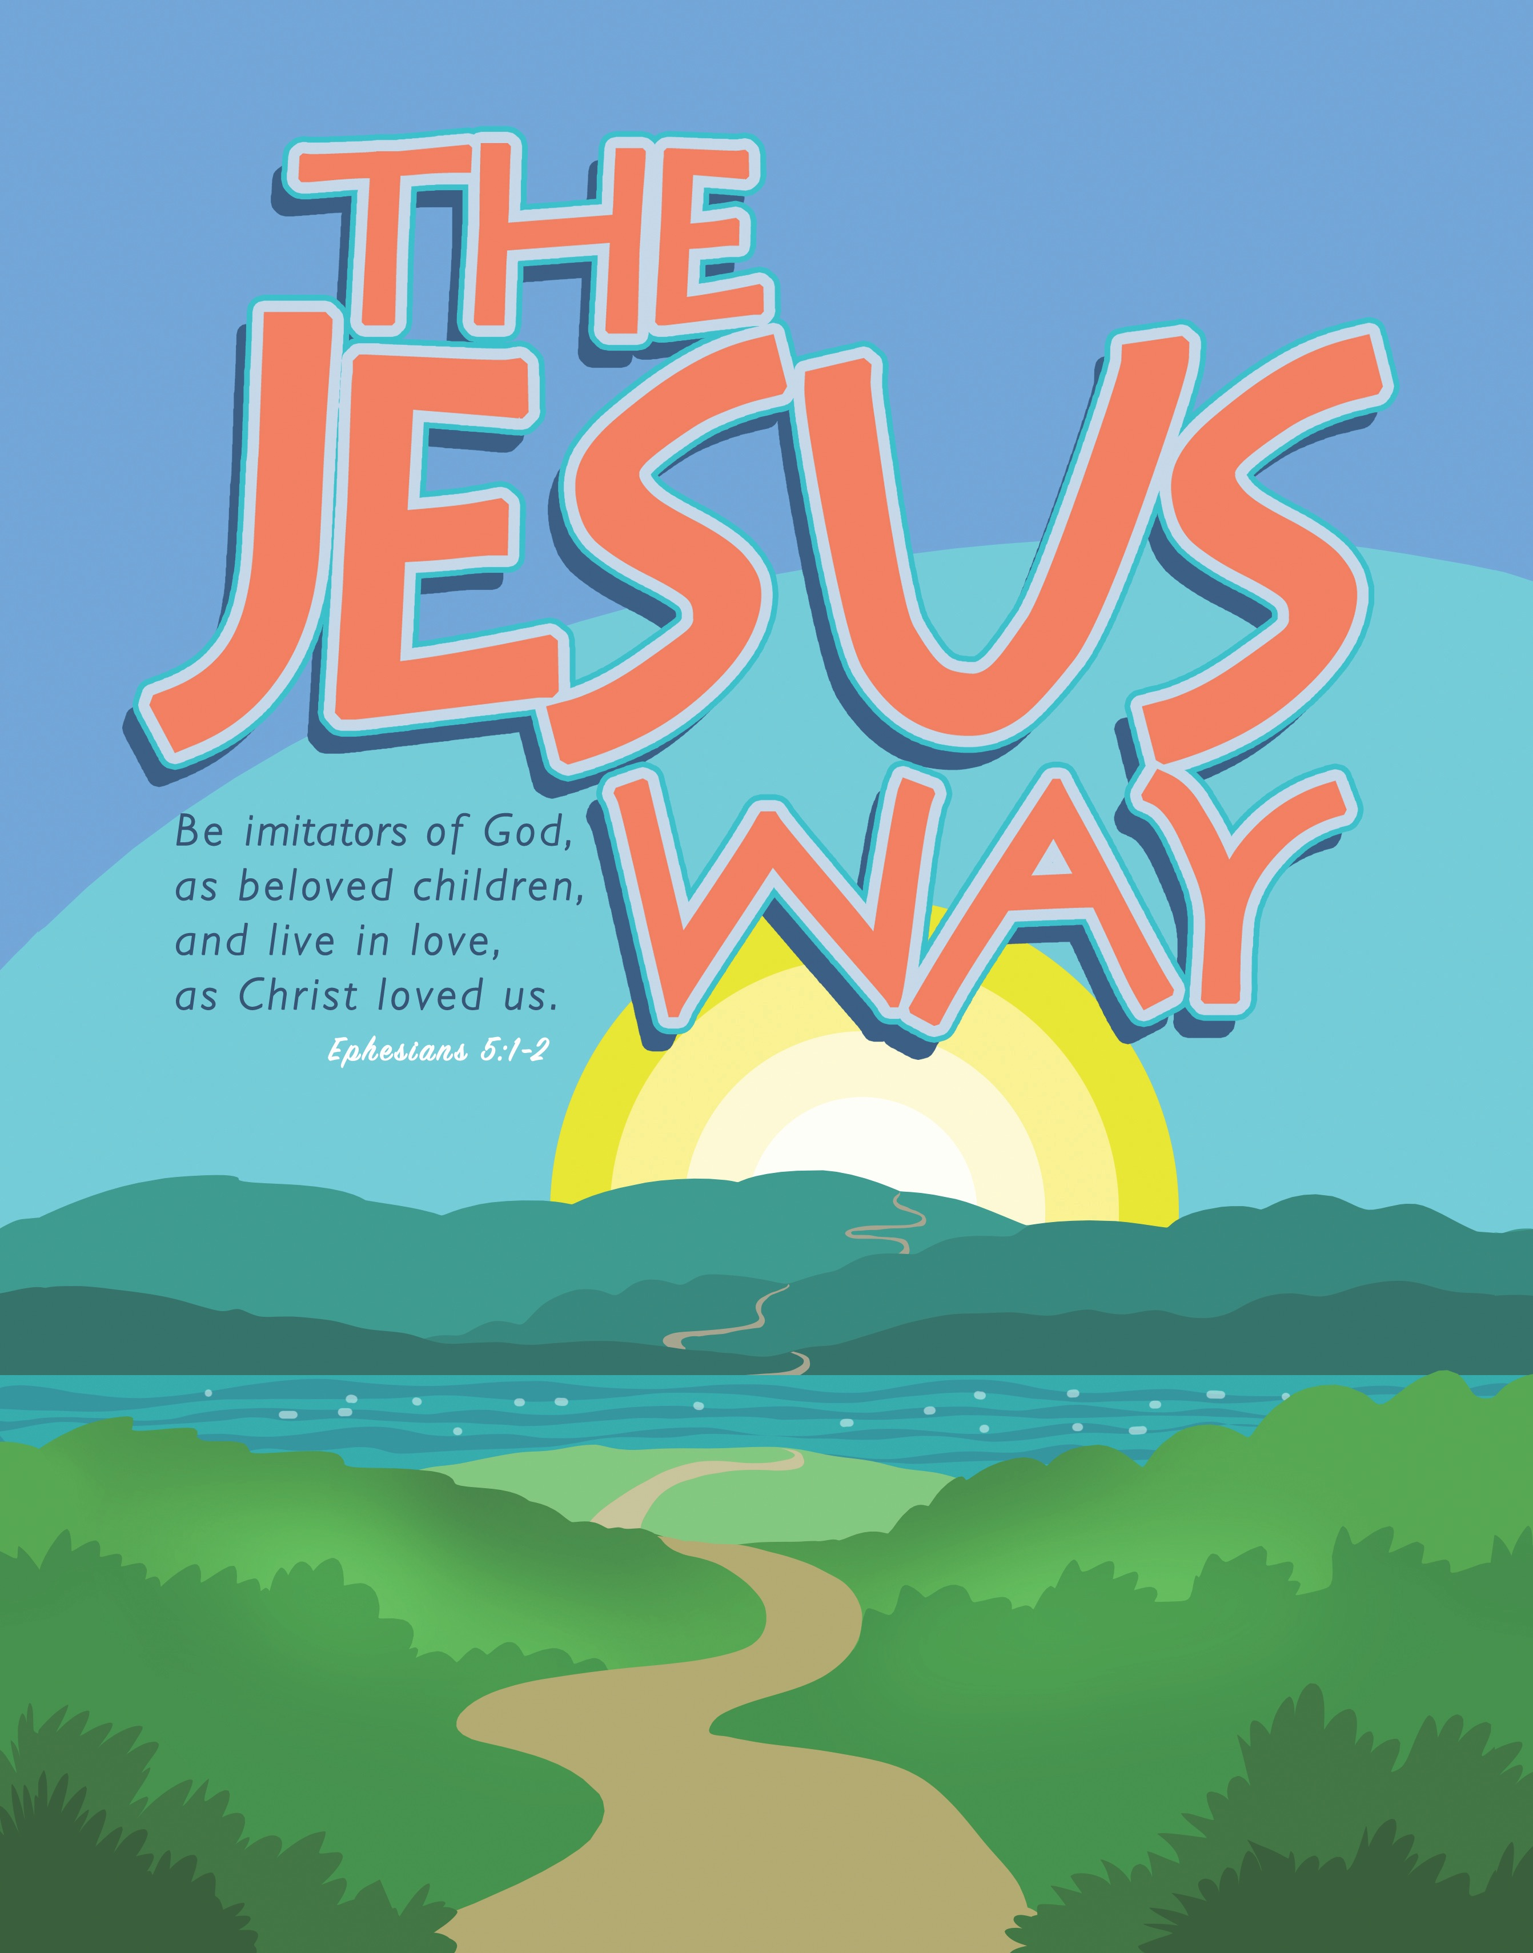
Cross Roads Day Camp 2016

Wharton United Community Church
July 25 – 29, 2016 9 a.m. to 3 p.m.

Children entering grades K - 5
$100 per child

Join us for an awesome week of action-packed camp fun! Kids will make cool crafts, engage in worship, sing fun songs, jump into Bible Study, and play zany games! All activities work together to form great friendships and strengthen campers’ faith development.

The Cross Roads Camp Staff is certified in American Red Cross CPR and First Aid and receives extensive training to deliver a safe and action-packed camp program.

Campers are asked to bring a sack lunch.
Complete this form and return it to your church. Registration form, health form, and payment must be received by start of Day Camp.
_________________________________________________________________________________________________
2016 Day Camp REGISTRATION FORM
Wharton United Community Church
20 Church Street, Wharton, NJ 07885

Please submit one form for each child who will be attending along with a completed health form.

Camper’s Name: ________________________________________ Date of Birth:_______________

Parents’ Names:_______________________________________ Grade Entering Fall 2016_______

Mailing Address:___________________________________________________________________

Home Phone:_______________________ Work/Cell Phone:_____________________________

Siblings (names, ages):______________________________________________________________

Church affiliation: __________________________________________________________________
My child has permission to participate in all aspects of the day camp program led by Cross Roads, except as noted. I understand that every effort will be made to contact me if my child needs emergency medical-surgical treatment. I hereby give my permission to the medical personnel selected by the congregation to secure proper treatment, to hospitalize, to order injection, anesthesia, x-ray, or surgery for my child as named above, and to arrange for or provide necessary related transportation. I understand that my insurance has primary coverage and Cross Roads’ insurance is secondary. I give my approval to photocopy this form for use out of camp. Further, I give permission for use of photos of my son/daughter to be used in camp promotion unless noted.
Parent/Guardian Signature __________________________________________________ Date ______________

